**Experiment No: 01**

#### 1. Pandas Library:

**Code:**

1. **Importing Libraries:**

* import pandas as pd: We import Pandas as pd, which is a common alias used by the community for convenience.
* import numpy as np: Numpy is imported as np, though it's not used in this script, it's often used alongside Pandas for numerical operations.

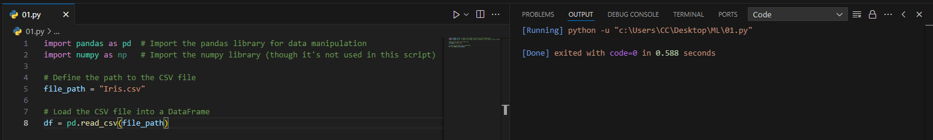



1. **Loading Data:**

* The CSV file Iris.csv is loaded into a DataFrame using pd.read_csv(file_path), where file_path is the path to the CSV file.





1. **Data Exploration:**

* df.head() displays the first few rows of the DataFrame, giving a quick glance at the data.

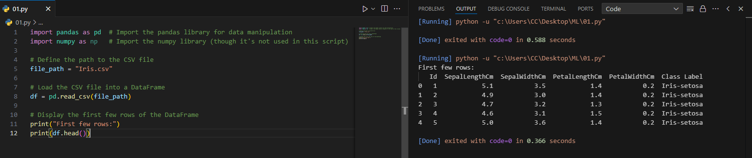



* df.tail() shows the last few rows, which is useful for checking the end of the data.

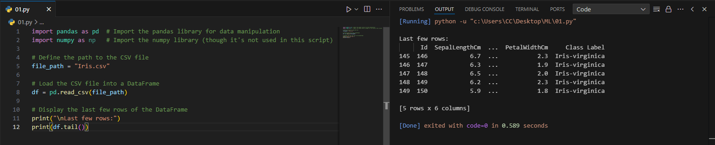



1. **Data Structure and Information:**

* df.shape gives the number of rows and columns, helping understand the size of the dataset.

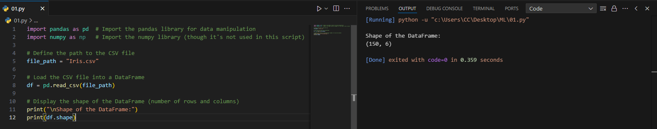



* df.info() provides a summary of the DataFrame, including data types and the count of non-null values for each column.

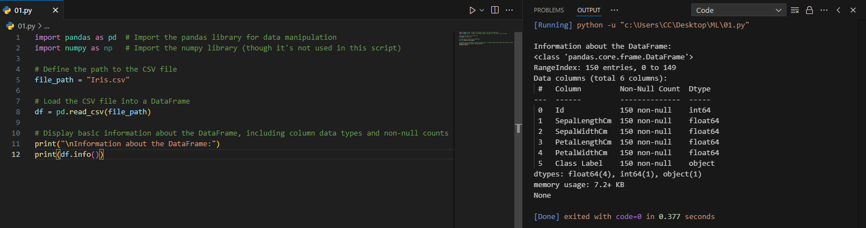



1. **Data Size and Missing Values:**

* df.size returns the total number of elements in the DataFrame, which is the product of rows and columns

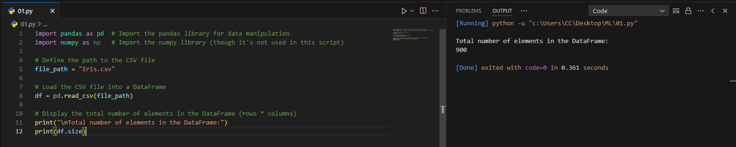



* df.isna() checks for missing values in the DataFrame and returns a DataFrame of the same shape with boolean values (True for missing values). df.isna().sum() gives the total count of missing values for each column.

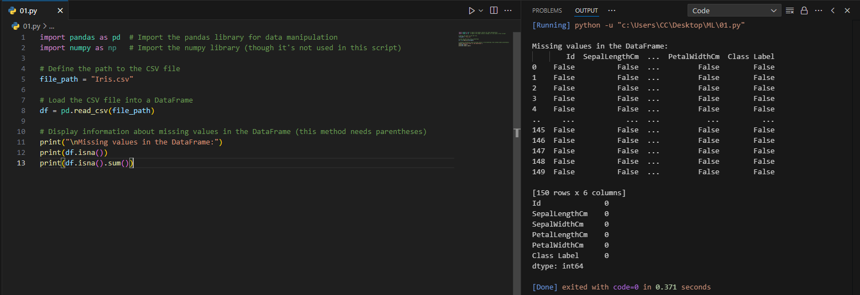



1. **Descriptive Statistics:**

* df.describe() generates descriptive statistics like mean, standard deviation, min, max, and percentiles for each numerical column.

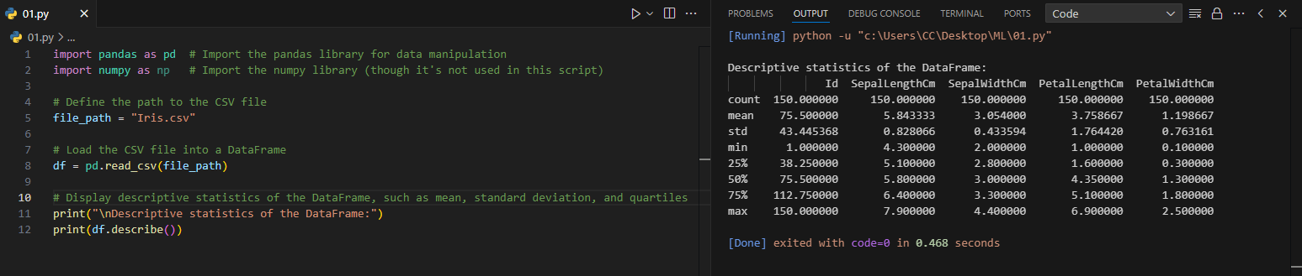



1. **Unique Values:**

* df.nunique() counts the number of unique values in each column, which is helpful in understanding the variability of the data.

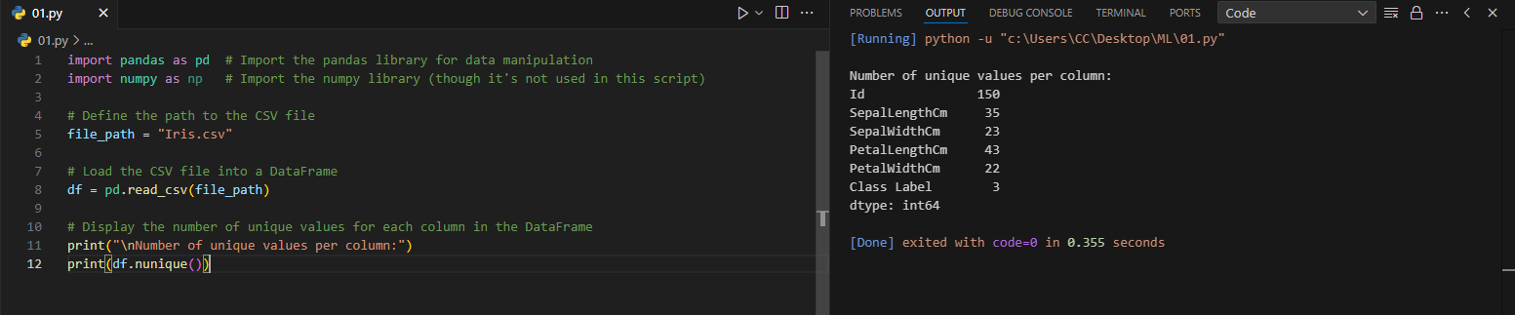



#### 2. NumPy Library:

**Code: -**

**1. Creating a NumPy Array**

* np.array(): Creates a NumPy array from a list or other iterable, enabling array operations.

**2. Finding Minimum Value**

* np.min(): Returns the minimum value from the array.

**3. Finding Maximum Value**

* np.max(): Returns the maximum value from the array.

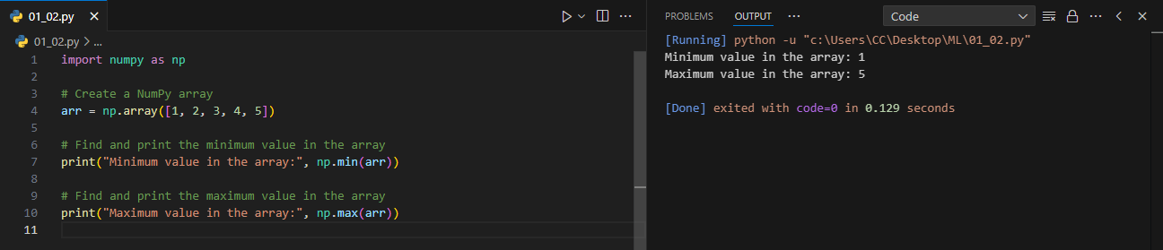



**4. Computing Mean**

* np.mean(): Computes the arithmetic mean (average) of the elements in the array.

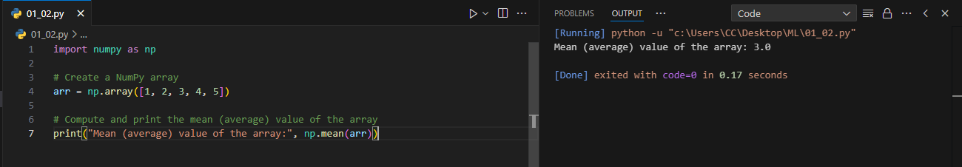



**5. Computing Standard Deviation**

* np.std(): Calculates the standard deviation, which measures the amount of variation or dispersion of a set of values.

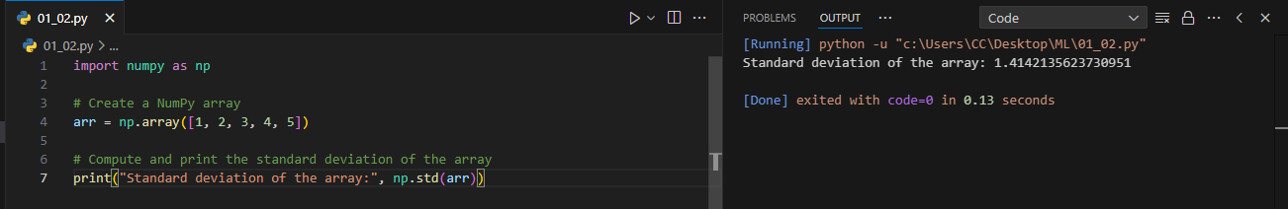



**6. Computing Median**

* np.median(): Finds the median value, which is the middle value when the array is sorted.

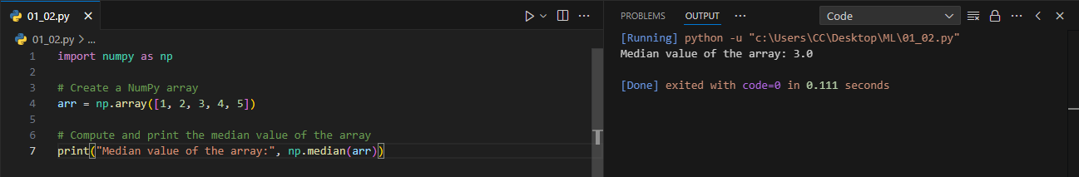



**7. Computing Percentile**

* np.percentile(): Returns the nth percentile of the array. The 50th percentile is the median.

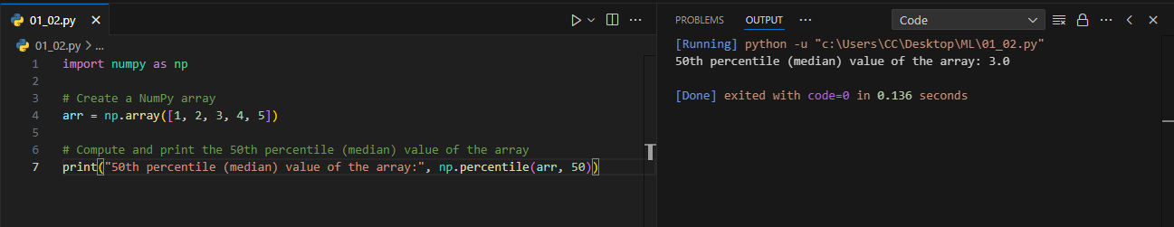



**8. Generating Linearly Spaced Numbers**

* np.linspace(): Generates an array of evenly spaced numbers over a specified range.

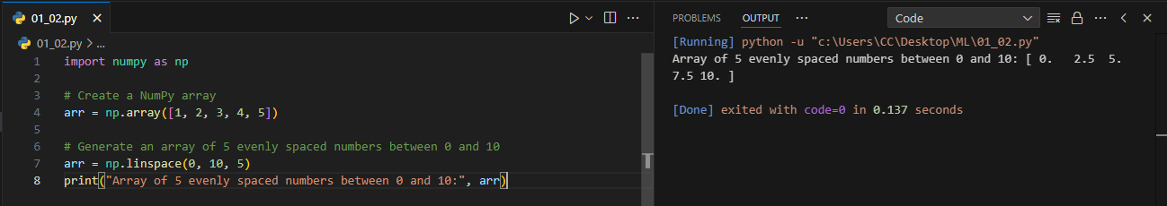



**9. Creating a 2D Array and Getting Array Shape**

* np.array(): Used again to create a 2D NumPy array.
* .shape: Returns a tuple representing the dimensions (number of rows and columns) of the array.

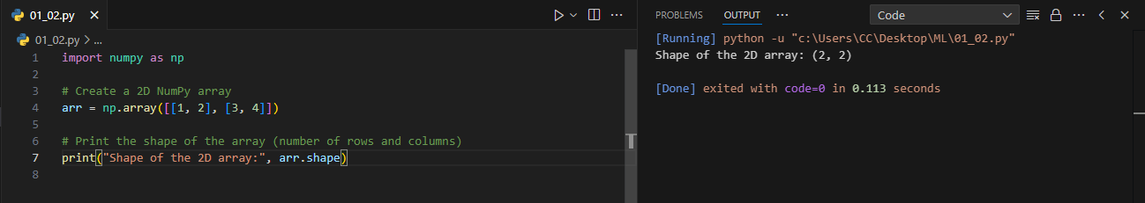



**10. Reshaping an Array**

* .reshape(): Changes the shape of an array without changing its data, here reshaping a 1D array into a 2D array.

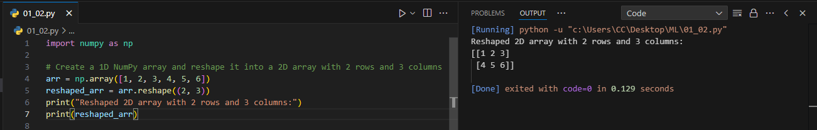



**11. Copying Values Between Arrays**

* np.copyto(): Copies values from one array (source) to another (destination), modifying the destination array in place.

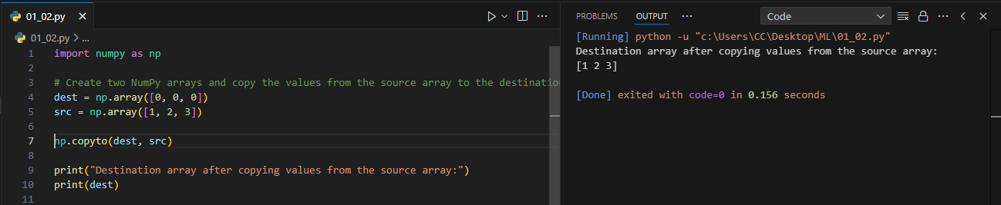



**12. Transposing an Array**

* .T: Transposes the array, swapping rows with columns.

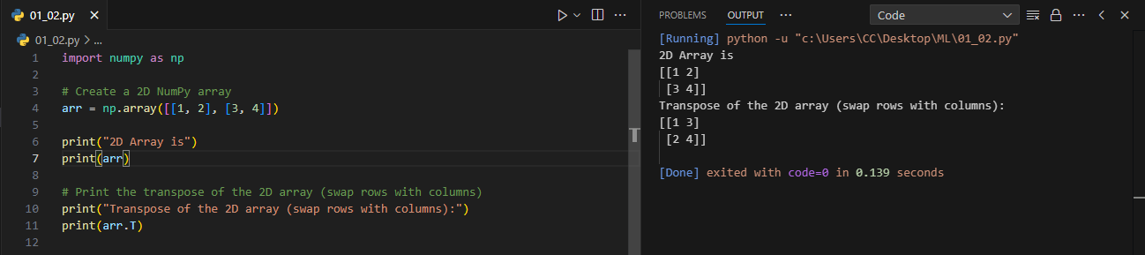



**13. Stacking Arrays**

* np.stack(): Combines arrays along a new axis, here stacking them row-wise.

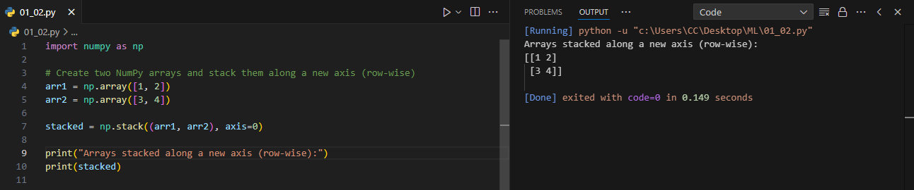



**14. Vertical Stacking and Horizontal Stacking**

* np.vstack(): Vertically stacks arrays, adding rows to form a new array.
* np.hstack(): Horizontally stacks arrays, adding columns to form a new array.

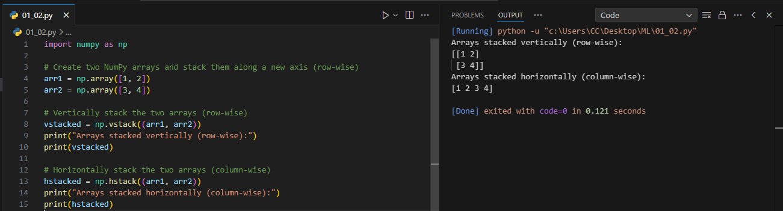



### *Matplotlib Library*

**1. Creating Graph**

1. Creating a Scatter Plot
   1. .plot(): A method from a pandas DataFrame that allows you to create various types of plots. Here, `kind='scatter'` specifies a scatter plot, and the `x` and `y` parameters specify the columns used for the x-axis and y-axis, respectively.
2. Creating a Bar Chart
   1. .plot(): A method from a pandas DataFrame that generates plots. Here, `kind='bar'` specifies that a bar chart should be created, displaying the counts of each variety.
3. Creating a Line Chart
   1. .plot()`: A pandas method that generates plots from DataFrame or Series data. Here, `kind='line'` specifies a line chart, and `marker='o'` adds circular markers at each data point for visibility.

**2. Adding X-axis Label**

* plt.xlabel(): Sets the label for the x-axis in the plot, enhancing readability and providing context for the data.

**3. Adding Y-axis Label**

* plt.ylabel(): Sets the label for the y-axis in the plot, similar to `plt.xlabel()`, ensuring clarity for the viewer.

**4. Adding Title to the Plot**

* plt.title(): Assigns a title to the plot, summarizing the content or purpose of the visualization.

**5. Displaying the Plot**

* plt.show(): Renders and displays the current figure or plot. This function is essential for visualizing the created plot in a standalone window or inline, depending on the environment.

**Code: -**

* 1. **Bar Chart**

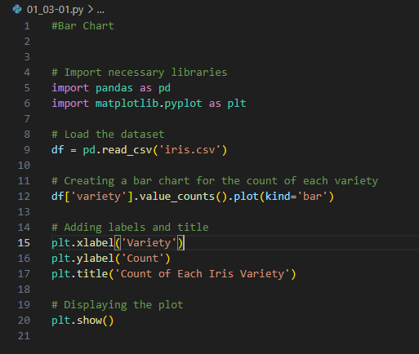

**Output: -**

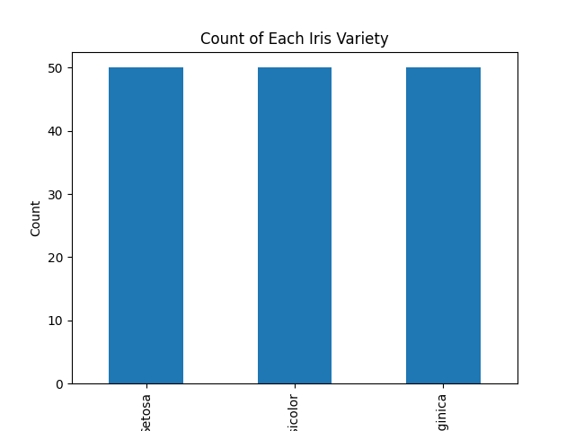

* 1. **Line Chart**

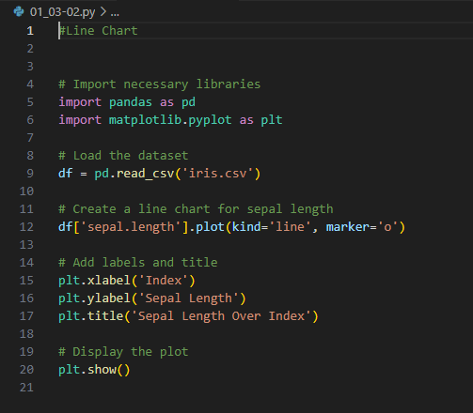

**Output: -**

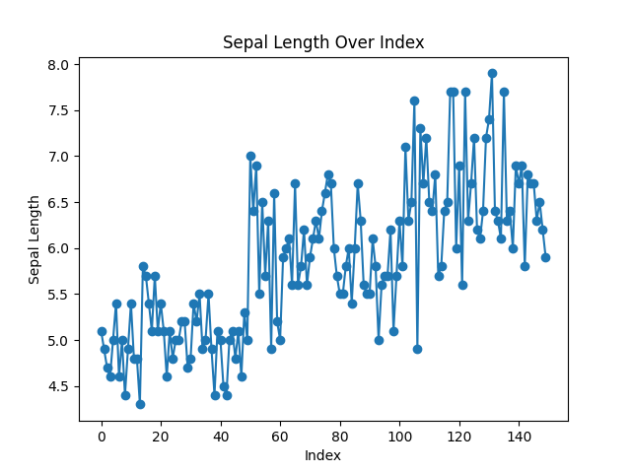

* 1. **Scatter Plot**

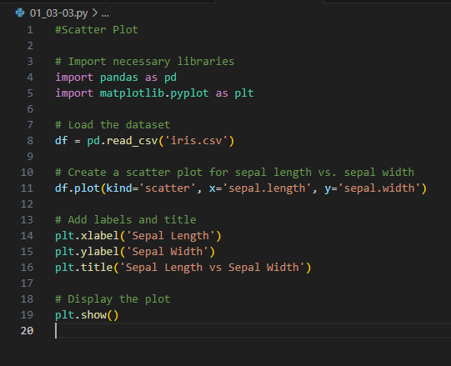

**Output:-**

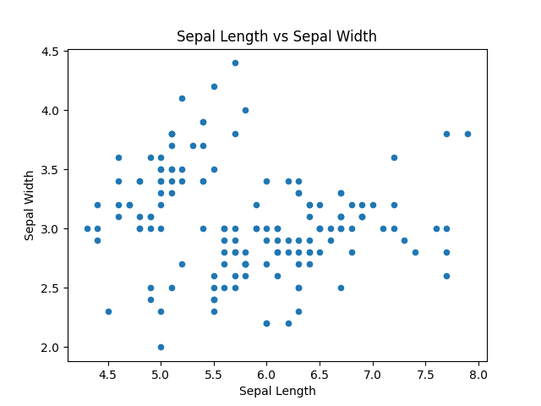

**Experiment No: 02**

**Code :-**

import matplotlib.pyplot as plt

from sklearn.metrics import confusion_matrix

x_true = [1, 0, 2, 2, 1, 0]

x_pred = [2, 0, 2, 2, 0, 0]

print(confusion_matrix(x_true, x_pred))

y_true = ["cat", "ant", "cat", "ant", "cat", "bird"]

y_pred = ["cat", "ant", "ant", "cat", "ant", "cat"]

print(confusion_matrix(y_true, y_pred, labels = ["ant", "cat", "bird"]))

from sklearn.datasets import load_breast_cancer

from sklearn.ensemble import RandomForestClassifier

from sklearn.model_selection import train_test_split

# Loading the breast cancer data set

diabetes_data = load_breast_cancer()

# Creating independent and dependent variables

X = diabetes_data.data

y = diabetes_data.target

# Splitting the data into training and testing set

X_train, X_test, y_train, y_test = train_test_split(X, y, test_size=0.2,

random_state=24)

print(f"Train Data: {X_train.shape}, {y_train.shape}")

print(f"Test Data: {X_test.shape}, {y_test.shape}")

# Training a binary classifier using Random Forest Algorithm with default hyperparameters

classifier = RandomForestClassifier(random_state=18)

classifier.fit(X_train, y_train)

# Here X_test, y_test are the test data points

predictions = classifier.predict(X_test)

#Importing all necessary libraries

from sklearn.metrics import accuracy_score

# Calculating the accuracy of classifier

print(f"Accuracy of the classifier is: {accuracy_score(y_test, predictions)}")

import matplotlib.pyplot as plt

from sklearn.metrics import confusion_matrix

from sklearn.metrics import ConfusionMatrixDisplay

# Compute and print the confusion matrix

cm = confusion_matrix(y_test, predictions)

# Plot the confusion matrix

disp = ConfusionMatrixDisplay(confusion_matrix=cm, display_labels=diabetes_data.target_names)

disp.plot()

plt.show()

**Output :-**

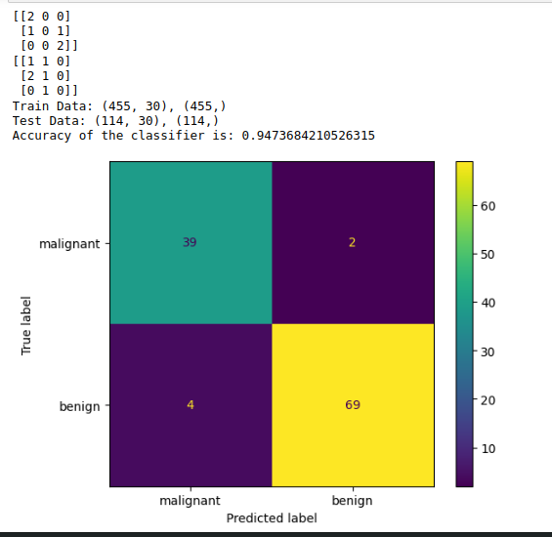

**Experiment No: 03**

**Code 01 :-**

import pandas as pd

from sklearn.model_selection import train_test_split

from sklearn.metrics import accuracy_score

from sklearn.neighbors import KNeighborsClassifier

# Load the dataset

file = "diabetes.csv"

df = pd.read_csv(file)

# Separate features and target variable

data = df.values

X, y = data[:, :-1], data[:, -1]

print(f"Feature shape: {X.shape}, Target shape: {y.shape}")

# Split the dataset into training and testing sets

X_train, X_test, y_train, y_test = train_test_split(X, y, test_size=0.3, random_state=1)

print(f"Training feature shape: {X_train.shape}, Testing feature shape: {X_test.shape}")

print(f"Training target shape: {y_train.shape}, Testing target shape: {y_test.shape}")

# Initialize and fit the KNN model

model = KNeighborsClassifier()

model.fit(X_train, y_train)

# Make predictions

y_predict = model.predict(X_test)

# Calculate and print accuracy

accuracy = accuracy_score(y_test, y_predict)

print("Dataframe:\n", df.head()) # Print only the first few rows for clarity

print("Accuracy: {:.2f}%".format(accuracy * 100))

**Code 01 Output :-**

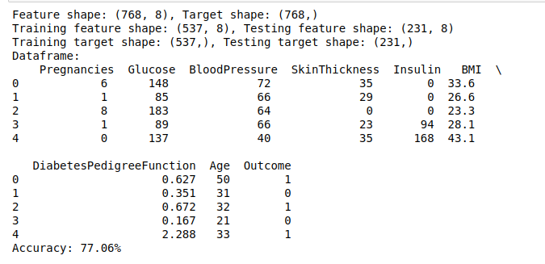

**Code 02 :-**

import numpy as np

import pandas as pd

from sklearn.model_selection import train_test_split

# Define arrays for X and y

X = np.array([

[1, 2, 3],

[4, 5, 6],

[7, 8, 9],

[10, 11, 12],

[13, 14, 15],

[16, 17, 18],

[19, 20, 21],

[22, 23, 24],

[25, 26, 27],

[28, 29, 30]

])

y = np.array([1, 2, 3, 4, 5, 6, 7, 8, 9, 10])

# Converting to pandas DataFrame for consistency

df = pd.DataFrame(X, columns=['Feature1', 'Feature2', 'Feature3'])

df['Target'] = y

# Separating features and target variable

X = df.iloc[:, :-1] # Features

y = df.iloc[:, -1] # Target variable

# Spliting the dataset into training and testing sets

X_train, X_test, y_train, y_test = train_test_split(X, y, test_size=0.3, random_state=0)

# Print the training and testing sets

print("X_train:")

print(X_train)

print("\nX_test:")

print(X_test)

print("\ny_train:")

print(y_train)

print("\ny_test:")

print(y_test)

**Code 02 Output :-**

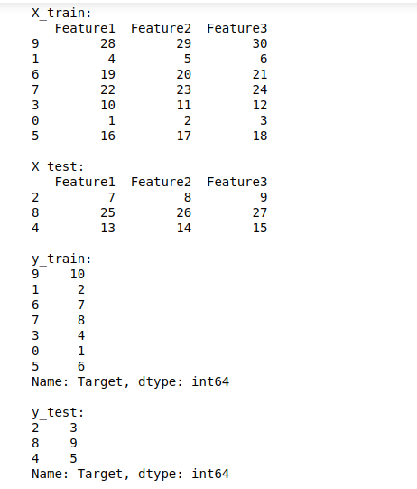

**Experiment No: 04**

**Code :-**

import numpy as np

import matplotlib.pyplot as plt

import pandas as pd

from sklearn.model_selection import train_test_split

from sklearn.linear_model import LinearRegression

# Importing the dataset

dataset = pd.read_csv('Salary_Dataset.csv')

X = dataset.iloc[:, 0:1].values # Features (Years of Experience)

y = dataset.iloc[:, 1].values # Target variable (Salary)

# Splitting the dataset into the Training set and Test set

X_train, X_test, y_train, y_test = train_test_split(X, y, test_size=0.25, random_state=0)

# Fitting the Linear Regression model

regressor = LinearRegression()

regressor.fit(X_train, y_train)

# Print shapes for debugging

print("X_train shape:", X_train.shape)

print("y_train shape:", y_train.shape)

print("X shape:", X.shape)

print("y shape:", y.shape)

# Visualizing the Training set results

plt.scatter(X_train, y_train, color='red')

plt.plot(X_train, regressor.predict(X_train), color='blue')

plt.title('Salary vs Experience (Training set)')

plt.xlabel('Years of Experience')

plt.ylabel('Salary')

plt.show()

# Visualizing the Test set results

plt.scatter(X_test, y_test, color='red')

plt.plot(X_train, regressor.predict(X_train), color='blue') # Using training data for the line

plt.title('Salary vs Experience (Test set)')

plt.xlabel('Years of Experience')

plt.ylabel('Salary')

plt.show()

# Predicting the Test set results

y_pred = regressor.predict(X_test)

# Displaying predictions

for pred in y_pred:

print("Predicted Salary:", pred)

**Code Output :-**

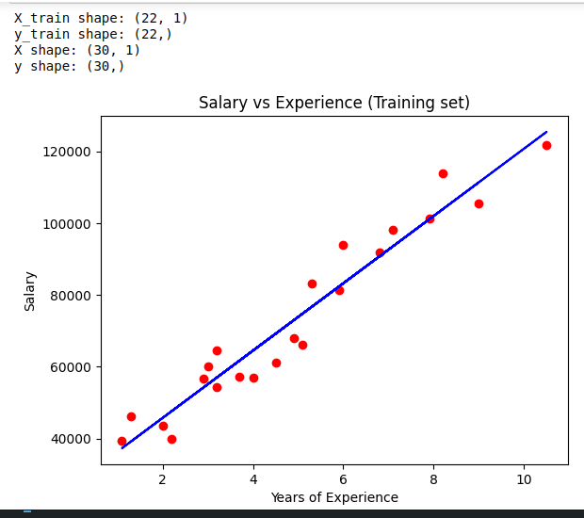

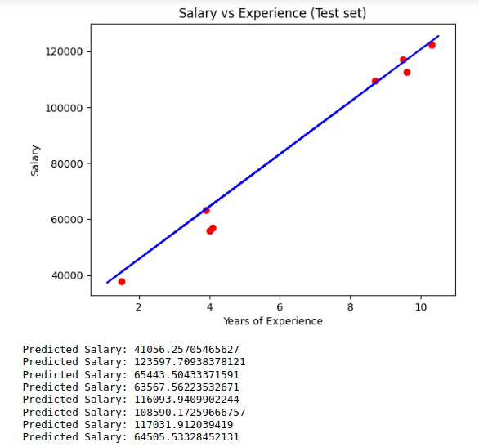

**Experiment No: 05**

**Code 01 :-**

import pandas as pd

import numpy as np

import matplotlib.pyplot as plt

import seaborn as sns

# Import warnings

import warnings

warnings.filterwarnings("ignore")

# We will use some methods from the sklearn module

from sklearn import linear_model

from sklearn.linear_model import LinearRegression

from sklearn import metrics

from sklearn.metrics import mean_squared_error, mean_absolute_error

from sklearn.model_selection import train_test_split, cross_val_score

# Load the dataset

df = pd.read_csv("Student_Performance.csv")

print(df.corr(numeric_only=True)) # Use numeric_only=True to only get numeric correlations

print(df.describe())

# Setting the value for X and y

X = df[['Hours_Studied', 'Previous_Scores']] # Adjusted features

y = df['Performance_Index'] # Adjusted target variable

# Visualizing the features

fig, axs = plt.subplots(2, figsize=(5, 10)) # Adjusted height for better spacing

plt1 = sns.boxplot(x=df['Hours_Studied'], ax=axs[0]) # Adjusted for the new feature

plt2 = sns.boxplot(x=df['Previous_Scores'], ax=axs[1]) # Adjusted for the new feature

plt.tight_layout()

sns.histplot(df['Performance_Index'], kde=True) # Changed to histplot with kde for better visualization

sns.pairplot(df, x_vars=['Hours_Studied', 'Previous_Scores'], y_vars='Performance_Index', height=4, aspect=1, kind='scatter')

plt.show()

# Create the correlation matrix and represent it as a heatmap.

sns.heatmap(df.corr(numeric_only=True), annot=True, cmap='coolwarm') # Use numeric_only=True for heatmap

plt.show()

X_train, X_test, y_train, y_test = train_test_split(X, y, test_size=0.3, random_state=100)

# Fitting the Multiple Linear Regression model

reg_model = LinearRegression().fit(X_train, y_train)

# Printing the model coefficients

print('Intercept: ', reg_model.intercept_)

# Pair the feature names with the coefficients

print(list(zip(X.columns, reg_model.coef_))) # Corrected to use .columns for feature names

# Predicting the Test and Train set result

y_pred = reg_model.predict(X_test)

x_pred = reg_model.predict(X_train) # This is actually predicting on the train set

print("Prediction for test set: {}".format(y_pred))

# Actual value and the predicted value

reg_model_diff = pd.DataFrame({'Actual value': y_test, 'Predicted value': y_pred})

print(reg_model_diff) # Added print to display the DataFrame

mae = metrics.mean_absolute_error(y_test, y_pred)

mse = metrics.mean_squared_error(y_test, y_pred)

r2 = np.sqrt(mse) # Changed to use mse instead of mean_squared_error directly

print('Mean Absolute Error:', mae)

print('Mean Square Error:', mse)

print('Root Mean Square Error:', r2)

**Code 01 Output :-**

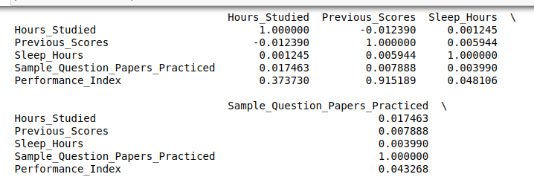

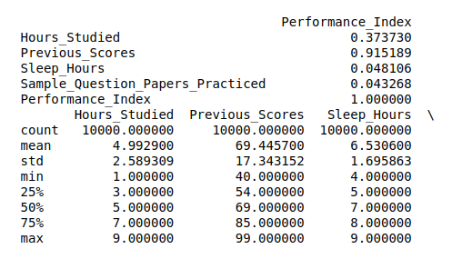

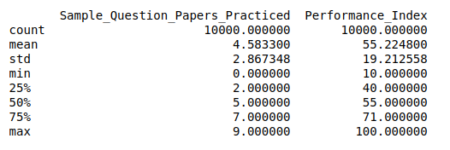

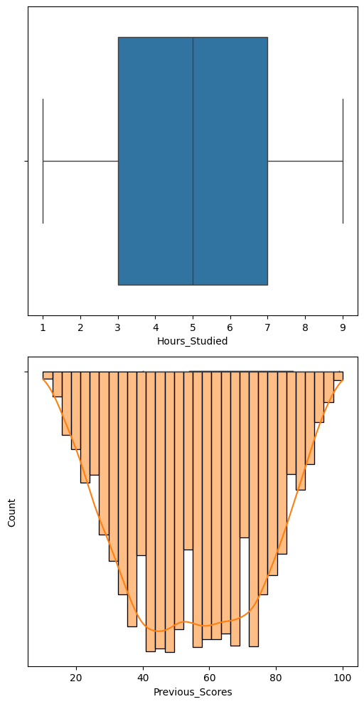

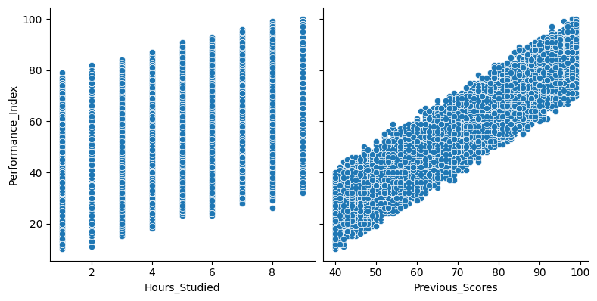

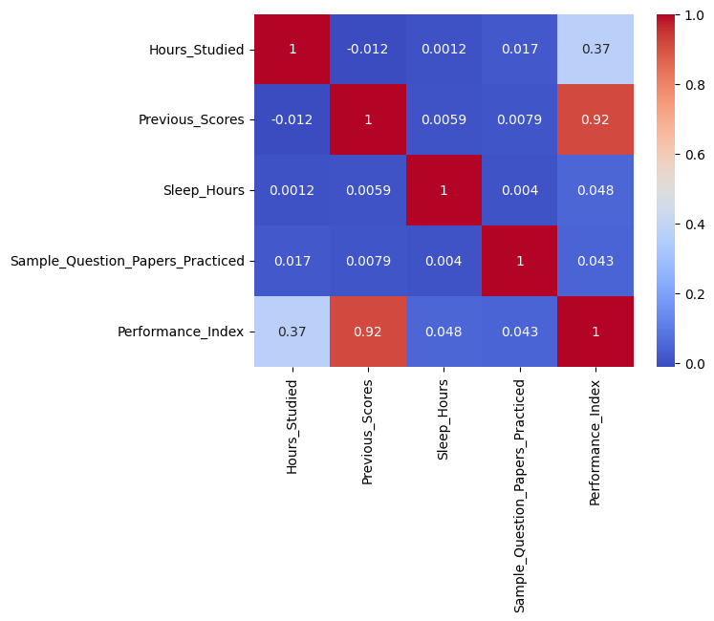

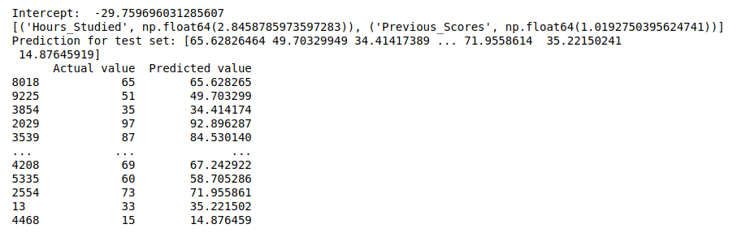

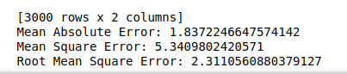

**Code 02 :-**

# Import necessary libraries

import pandas as pd

import numpy as np

import matplotlib.pyplot as plt

import seaborn as sns

from sklearn import linear_model

from sklearn.model_selection import train_test_split

from sklearn import metrics

# Load the dataset

df = pd.read_csv("Student_Performance.csv")

# Prepare the features and target variable

X = df[['Hours_Studied', 'Previous_Scores']] # Adjusted features

y = df['Performance_Index'] # Adjusted target variable

# Perform exploratory data analysis

print(df.corr(numeric_only=True)) # Only get numeric correlations

sns.pairplot(df, x_vars=['Hours_Studied', 'Previous_Scores'], y_vars='Performance_Index', height=4, aspect=1, kind='scatter')

plt.show()

# Split the data into training and testing sets

X_train, X_test, y_train, y_test = train_test_split(X, y, test_size=0.3, random_state=42)

# Create and fit the multivariable regression model

reg_model = linear_model.LinearRegression()

reg_model.fit(X_train, y_train)

# Print model coefficients

print('Intercept:', reg_model.intercept_)

print('Coefficients:', reg_model.coef_)

# Make predictions

y_pred = reg_model.predict(X_test)

# Evaluate the model

mae = metrics.mean_absolute_error(y_test, y_pred)

mse = metrics.mean_squared_error(y_test, y_pred)

r2 = metrics.r2_score(y_test, y_pred)

print('Mean Absolute Error:', mae)

print('Mean Squared Error:', mse)

print('R-squared:', r2)

# Visualize actual vs predicted values

plt.scatter(y_test, y_pred)

plt.xlabel('Actual Performance Index')

plt.ylabel('Predicted Performance Index')

plt.title('Actual vs Predicted Performance Index')

plt.plot([y.min(), y.max()], [y.min(), y.max()], 'r--') # 45-degree line

plt.show()

**Code 02 Output: -**

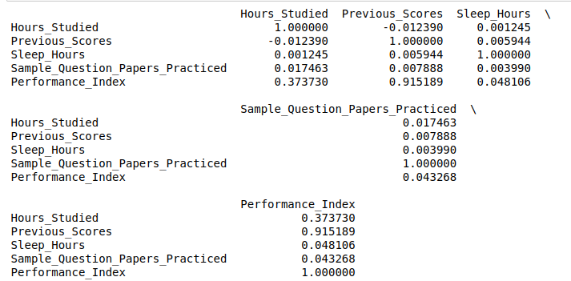



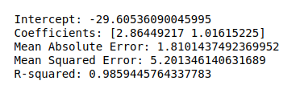

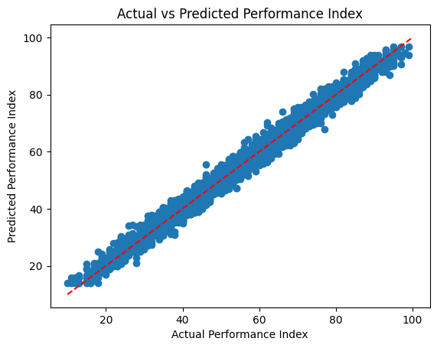

**Experiment No: 06**

**Code:**

# Import libraries

import sys

import matplotlib

matplotlib.use('Agg')

import pandas as pd

from sklearn import tree

from sklearn.tree import DecisionTreeClassifier

import matplotlib.pyplot as plt

# Load the data

df = pd.read_csv(r"D:\[Current_Learning]\TY_NOTES\ML\Practical\Exp_No_06\Experiment6.csv")

# Map categorical variables to numerical values

nationality_map = {'UK': 1, 'USA': 0, 'N': 2}

df['Nationality'] = df['Nationality'].map(nationality_map)

go_map = {'YES': 1, 'NO': 0}

df['Go'] = df['Go'].map(go_map)

# Define all possible feature pairs to explore

feature_combinations = [

    ['Age', 'Experience'],

    ['Age', 'Rank'],

    ['Age', 'Nationality'],

    ['Experience', 'Rank'],

    ['Experience', 'Nationality'],

    ['Rank', 'Nationality']

]

# Iterate through each feature combination and plot the tree

for i, features in enumerate(feature_combinations):

    X = df[features]

    y = df['Go']

    # Initialize and fit the Decision Tree Classifier

    dtree = DecisionTreeClassifier()

    dtree.fit(X, y)

    # Plot the decision tree

    plt.figure(figsize=(10, 8))

    tree.plot_tree(dtree, feature_names=features, class_names=['NO', 'YES'], filled=True)

    # Save the plot with a unique name for each feature combination

    plt.savefig(f"decision_tree_{i+1}.png")

    plt.close()

print("Decision trees for different feature combinations have been saved.")

**Output:**

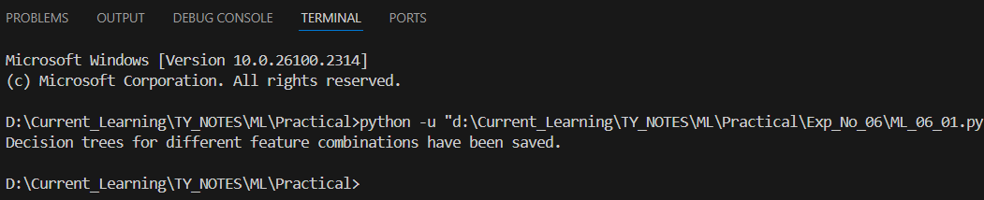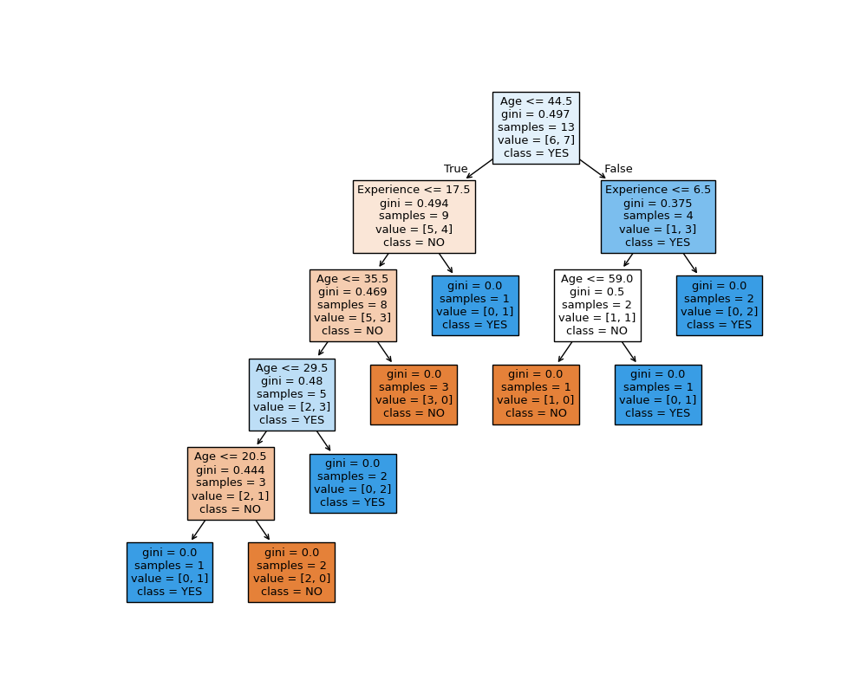

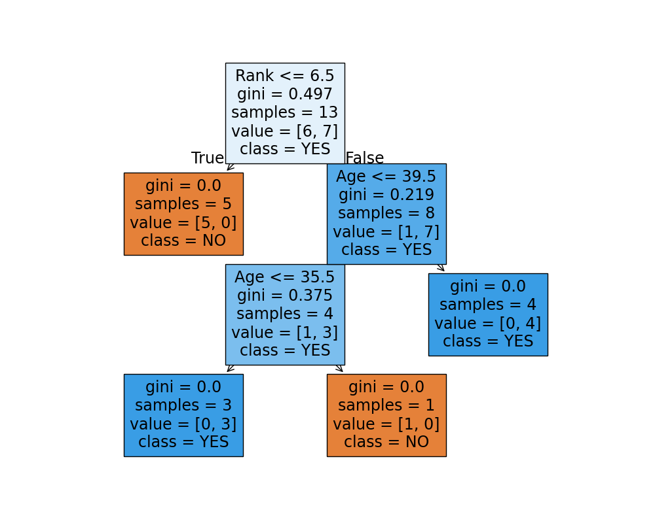

**Experiment No: 07**

**Code:**

import pandas as pd

from sklearn.model_selection import train_test_split

from sklearn.ensemble import RandomForestClassifier

from sklearn.preprocessing import LabelEncoder

from sklearn.metrics import classification_report, accuracy_score

# Load the data

data = pd.read_csv(r'D:\Current_Learning\TY_NOTES\ML\Practical\Exp_No_07\Experiment7.csv')

# Check for missing values in categorical columns

data.fillna({'Sex': 'unknown', 'Embarked': 'unknown'}, inplace=True)

# data['Sex'] = data['Sex'].fillna('unknown')

# data['Embarked'] = data['Embarked'].fillna('unknown')

# Encode categorical variables

label_encoder = LabelEncoder()

data['Sex'] = label_encoder.fit_transform(data['Sex'])

data['Embarked'] = label_encoder.fit_transform(data['Embarked'])

# Define features and target variable

X = data.drop(columns=['Survived'])

y = data['Survived']

# Split the data into training and testing sets

X_train, X_test, y_train, y_test = train_test_split(X, y, test_size=0.3, random_state=42)

# Initialize and train the Random Forest Classifier

rf_model = RandomForestClassifier(random_state=42, n_estimators=100)

rf_model.fit(X_train, y_train)

# Make predictions

y_pred = rf_model.predict(X_test)

# Evaluate the model

accuracy = accuracy_score(y_test, y_pred)

report = classification_report(y_test, y_pred)

print(f"Accuracy: {accuracy * 100:.2f}%")

print("Classification Report:\n", report)

**Output:**

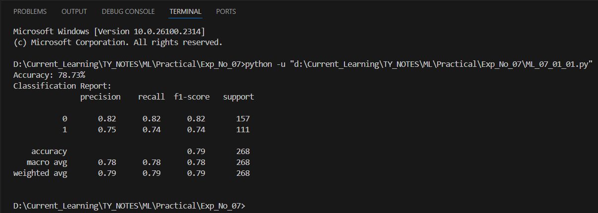

**Experiment No: 08**

**Code:**

from sklearn.model_selection import train_test_split

from sklearn.naive_bayes import GaussianNB

from sklearn.metrics import accuracy_score

import matplotlib.pyplot as plt

import seaborn as sns

import pandas as pd

import numpy as np

import warnings

# Ignore warnings for cleaner output

warnings.filterwarnings('ignore')

# Load the dataset

glass = pd.read_csv(r"D:\Current_Learning\TY_NOTES\ML\Practical\Exp_No_08\Experiment8.csv")

# Print dataset information

print("Shape of dataset:", glass.shape)

print("Null values per column:\n", glass.isnull().sum())

# Plot distribution of Glass Types

plt.figure(figsize=(8, 6))

sns.countplot(x='Type', data=glass, color='red')

plt.title("Distribution of Glass Types")

plt.xlabel("Type")

plt.ylabel("Count")

plt.show()

# Initialize Gaussian Naive Bayes model

nb = GaussianNB()

# Separate features and target variable

X = glass.drop(columns=['Type'])

y = glass['Type']

# Split data into training and testing sets

X_train, X_test, y_train, y_test = train_test_split(X, y, test_size=0.2, random_state=4)

# Train the model on the training data

nb.fit(X_train, y_train)

# Make predictions on the test set

y_pred = nb.predict(X_test)

print("Predicted values:", y_pred)

# Calculate and print accuracy

accuracy = accuracy_score(y_test, y_pred)

print("Accuracy Score:", accuracy)

**Output:**

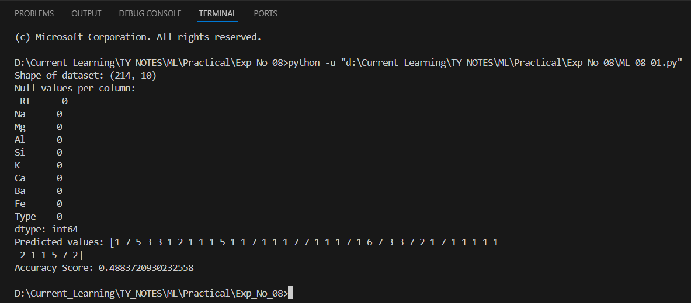

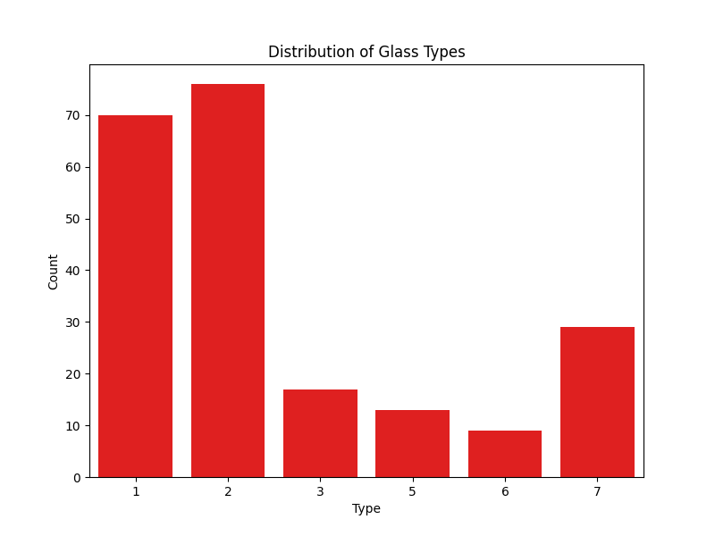

**Experiment No: 09**

**Code:**

import pandas as pd

from sklearn.model_selection import train_test_split

from sklearn.neighbors import KNeighborsClassifier

from sklearn.ensemble import RandomForestClassifier

from sklearn.preprocessing import LabelEncoder

from sklearn.metrics import confusion_matrix, classification_report, accuracy_score

import matplotlib

matplotlib.use('Agg')  # Use non-interactive backend

import matplotlib.pyplot as plt

import seaborn as sns

# Load the data

data = pd.read_csv(r'D:\Current_Learning\TY_NOTES\ML\Practical\Exp_No_09\Experiment9.csv')

# Print columns to verify

print("Columns in dataset:", data.columns)

# Encode categorical variables

label_encoder = LabelEncoder()

if 'Gender' in data.columns:

    data['Gender'] = label_encoder.fit_transform(data['Gender'])

# Select features and the target variable for KNN

X_knn = data[['Age', 'Gender']]

y_knn = data['Purchased']

# Split data into training and testing sets for KNN

X_train_knn, X_test_knn, y_train_knn, y_test_knn = train_test_split(X_knn, y_knn, test_size=0.3, random_state=42)

# Initialize and train the KNN classifier

knn_classifier = KNeighborsClassifier(n_neighbors=5)

knn_classifier.fit(X_train_knn, y_train_knn)

# Make predictions on the test set

y_pred_knn = knn_classifier.predict(X_test_knn)

# Generate and display the confusion matrix

conf_matrix_knn = confusion_matrix(y_test_knn, y_pred_knn)

plt.figure(figsize=(8, 5))

sns.heatmap(conf_matrix_knn, annot=True, fmt="d", cmap="Blues", cbar=False,

            xticklabels=['Not Purchased', 'Purchased'], yticklabels=['Not Purchased', 'Purchased'])

plt.xlabel('Predicted Label')

plt.ylabel('True Label')

plt.title('KNN Classification Confusion Matrix')

# Save the figure instead of showing it

plt.savefig('knn_confusion_matrix.png')

plt.close()

# Print classification report for additional performance metrics

print("\nClassification Report for KNN:\n", classification_report(y_test_knn, y_pred_knn))

**Output:**

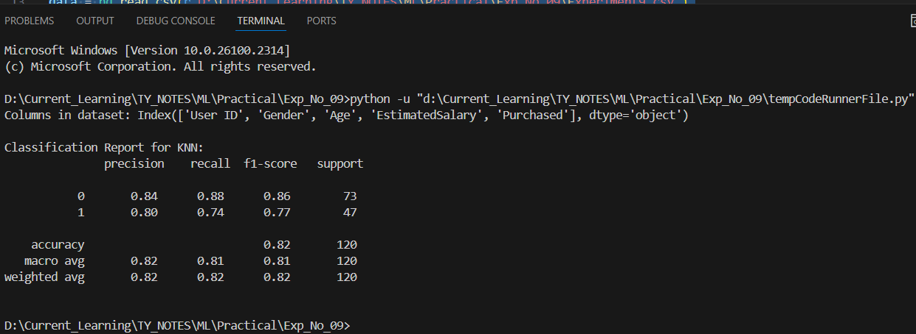

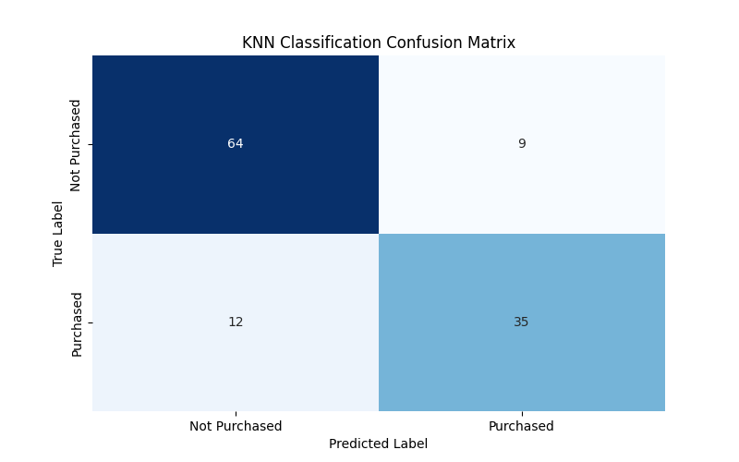

**Experiment No: 10**

**Code:**

import pandas as pd

from sklearn import svm

from sklearn.model_selection import train_test_split

from sklearn.preprocessing import LabelEncoder, StandardScaler

from sklearn.metrics import accuracy_score

# Load your dataset

data = pd.read_csv(r'D:\Current_Learning\TY_NOTES\ML\Practical\Exp_No_10\Experiment10.csv')

# Encode 'species' if it's categorical

if data['Species'].dtype == 'object':

    encoder = LabelEncoder()

    data['Species'] = encoder.fit_transform(data['Species'])

# Define features and target

X = data[['Weight', 'Width']]

y = data['Species']

# Split the data into training and testing sets

X_train, X_test, y_train, y_test = train_test_split(X, y, test_size=0.2, random_state=42)

scaler = StandardScaler()

X_train = scaler.fit_transform(X_train)

X_test = scaler.transform(X_test)

# Create and train the SVM classification model

model = svm.SVC()

model.fit(X_train, y_train)

y_pred = model.predict(X_test)

accuracy = accuracy_score(y_test, y_pred)

print(f"Model Accuracy: {accuracy:.2f}")

y_pred_labels = encoder.inverse_transform(y_pred)

print("SVM Predictions (Species):", y_pred_labels)

**Output:**

